1. How is the characteristics of the data? Do exploratory data analysis, calculate descriptive statistics, and visualize it.
2. Please Do preprocessing data. Is there any missing values or outliers? If yes, solve it and give some explanation. Do variable selection or dimension reduction if needed and give some explanation.
3. Find the best model and evaluate the model.

**ANSWER**

1. **Karakteristik Data** Ecommerce_Churn yaitu memiliki 8 tipe data Float, 7 tipe data Integer dan 5 tpe data object .

**Statistics Deskriptiv :**

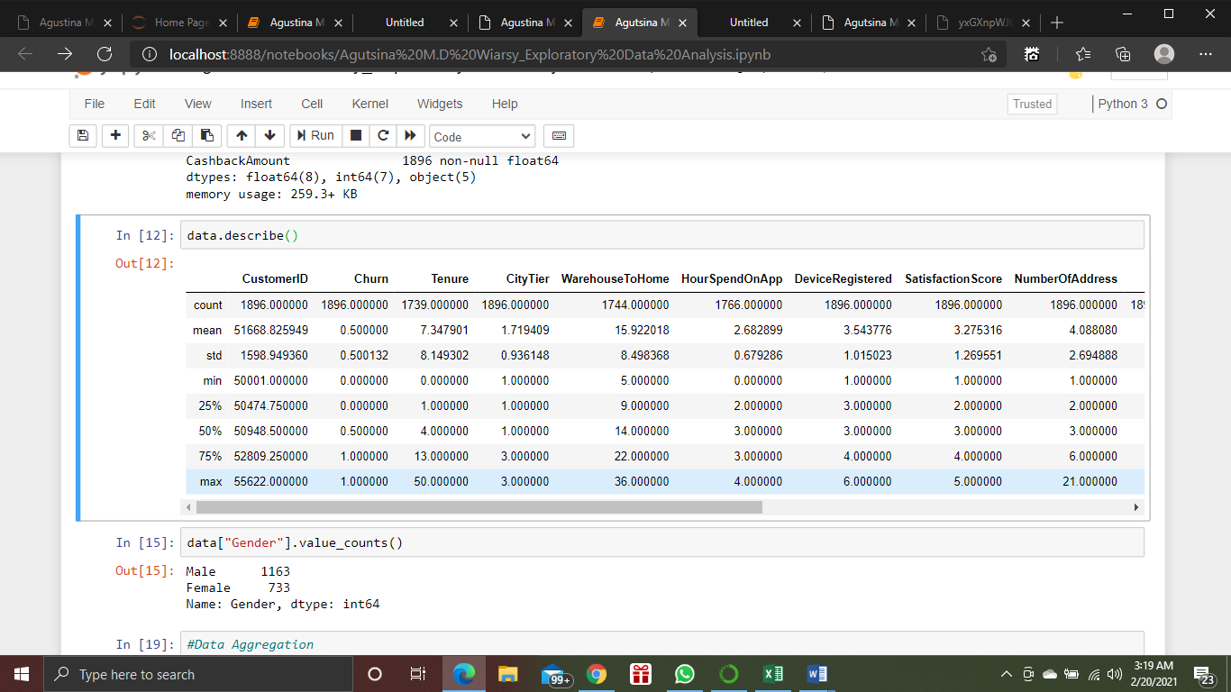

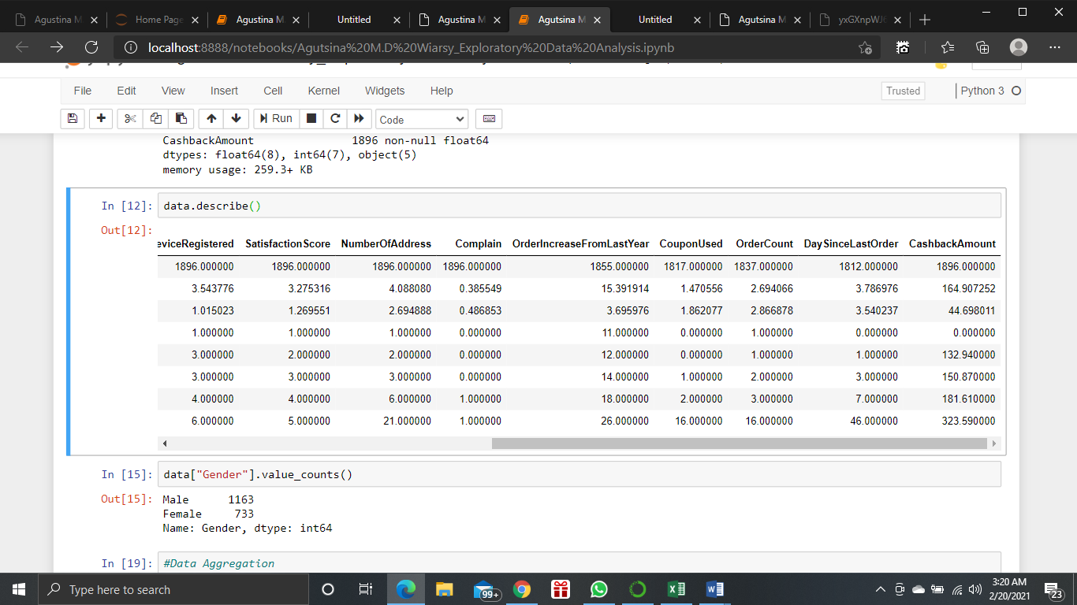

**Visuaalisasi**

Plot

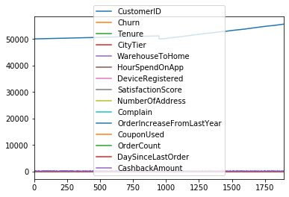

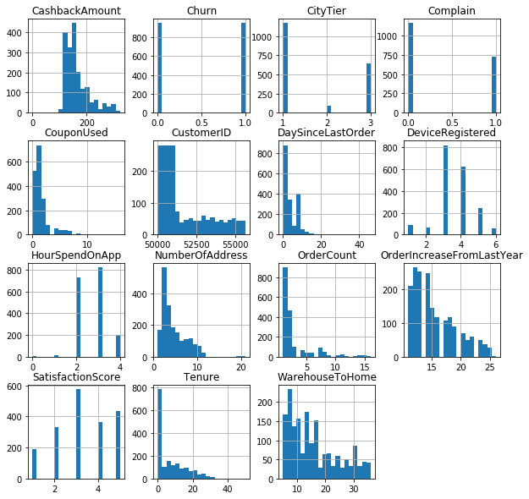

1. **Missing Value**

Terdapat nilai yang hilang pada 7 variabel, yaitu variabel Tenure, WarehouseToHome, HourSpendOnApp, OrderIncreaseFromLastYear, CouponUsed, OrderCount, dan variabel DaySinceLastOrder.

CustomerID 0

Churn 0

Tenure 157

PreferredLoginDevice 0

CityTier 0

WarehouseToHome 152

PreferredPaymentMode 0

Gender 0

HourSpendOnApp 130

DeviceRegistered 0

PreferedOrderCat 0

SatisfactionScore 0

MaritalStatus 0

NumberOfAddress 0

Complain 0

OrderIncreaseFromLastYear 41

CouponUsed 79

OrderCount 59

DaySinceLastOrder 84

CashbackAmount 0

dtype: int64